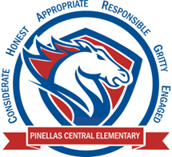

**Pinellas Central Elementary School**

**5th Grade School Supply List 2024-2025**

**Student Items (for individual student use)**

* 5 composition books (reading, writing, math (2), and homework)
* 1 spiral notebook for science
* 4 folders with pockets (reading, writing, math, science)
* 8 pack of dividers
* 1 ½ -inch 3 ring binder
* pencil pouch with rings to put in binder
* clear plastic pocket with holes to put in binder for homework
* highlighter
* colored pencils (12)
* chunk eraser
* wood pencils (no mechanical pencils)
* pen
* **1 pair of headphones or earbuds**